Modal Verbs

🔹 What is Modal Verbs
# Source: AI Source: Provided by: [Data Path: Persons Table -> ID Column: 1, Name_En Column: Motasem Essam] -> From: [Chatgpt (GPT-4-turbo)] on [7/27/2025]
Modal verbs are a special type of auxiliary (helping) verb used with the base form of a main verb to express meanings such as ability, possibility, necessity, permission, or advice.

✅ Definition:
# Source: AI Source: Provided by: [Data Path: Persons Table -> ID Column: 1, Name_En Column: Motasem Essam] -> From: [Chatgpt (GPT-4-turbo)] on [7/27/2025]
A modal verb is a helping verb that expresses the speaker’s attitude or mood toward the action — such as ability, necessity, possibility, or obligation.

🛠️ Modal + Base Verb = Verb Phrase
# Source: AI Source: Provided by: [Data Path: Persons Table -> ID Column: 1, Name_En Column: Motasem Essam] -> From: [Chatgpt (GPT-4-turbo)] on [7/27/2025]
📌 Example:
- She can swim. → "can" (modal) + "swim" (base verb)
- You must study. → "must" (modal) + "study" (base verb)

📚 Common Modal Verbs:
# Source: AI Source: Provided by: [Data Path: Persons Table -> ID Column: 1, Name_En Column: Motasem Essam] -> From: [Chatgpt (GPT-4-turbo)] on [7/27/2025]
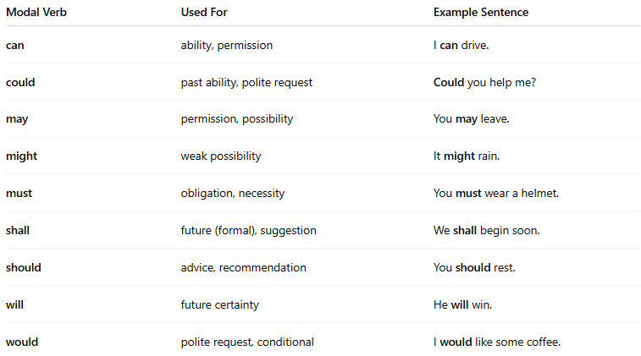
Modal Verb | Used For | Example Sentence
can | ability, permission | I can drive.
could | past ability, polite request | Could you help me?
may | permission, possibility | You may leave.
might | weak possibility | It might rain.
must | obligation, necessity | You must wear a helmet.
shall | future (formal), suggestion | We shall begin soon.
should | advice, recommendation | You should rest.
will | future certainty | He will win.
would | polite request, conditional | I would like some coffee.

⚠️ Characteristics of Modal Verbs:
# Source: AI Source: Provided by: [Data Path: Persons Table -> ID Column: 1, Name_En Column: Motasem Essam] -> From: [Chatgpt (GPT-4-turbo)] on [7/27/2025]
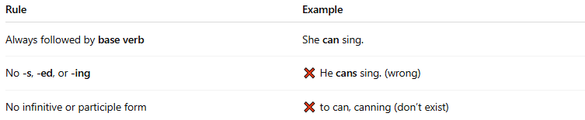

Rule | Example
Always followed by base verb | She can sing.
No -s, -ed, or -ing | ❌ He cans sing. (wrong)
No infinitive or participle form | ❌ to can, canning (don’t exist)

🧠 Modal Verb Functions Overview:
# Source: AI Source: Provided by: [Data Path: Persons Table -> ID Column: 1, Name_En Column: Motasem Essam] -> From: [Chatgpt (GPT-4-turbo)] on [7/27/2025]
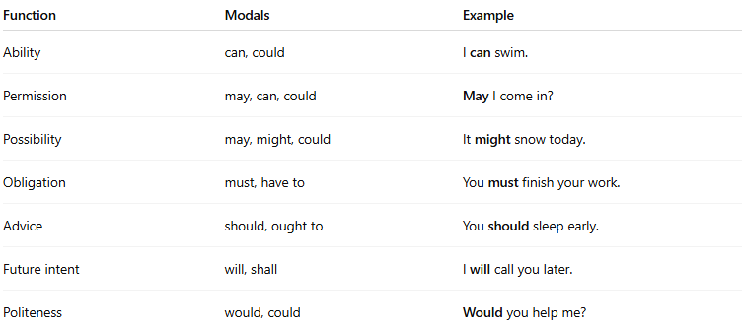
Function | Modals | Example
Ability | can, could | I can swim.
Permission | may, can, could | May I come in?
Possibility | may, might, could | It might snow today.
Obligation | must, have to | You must finish your work.
Advice | should, ought to | You should sleep early.
Future intent | will, shall | I will call you later.
Politeness | would, could | Would you help me?

✅ Summary Table:
# Source: AI Source: Provided by: [Data Path: Persons Table -> ID Column: 1, Name_En Column: Motasem Essam] -> From: [Chatgpt (GPT-4-turbo)] on [7/27/2025]
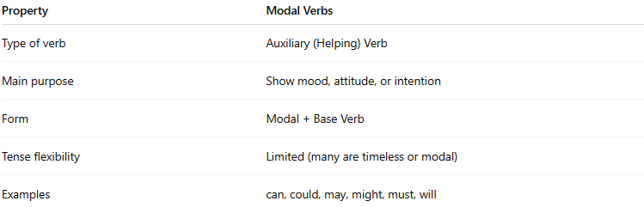
Property | Modal Verbs
Type of verb | Auxiliary (Helping) Verb
Main purpose | Show mood, attitude, or intention
Form | Modal + Base Verb
Tense flexibility | Limited (many are timeless or modal)
Examples | can, could, may, might, must, will

